***MEMBERS OF THE GROUP***

**ADM NO :**   **NAME** :

* BSCAS/2020/91649 MULEI NGINA PURITY
* BSCAS/2020/91657 MAINA PAULINE WAIRIMU
* BSCAS/2020/90535 OYARO ANGELINE OYARO
* BSCAS/2020/67375 KIPNETICH SAMMARY JEROTICH
* BSCAS/2020/91608 MANGICHO FAITH ACHIENG
* BSCAS/2020/67686 MARY MOTONGORI MOTABO
* BSCAS/2020/90626 MAURICE OWENGA
* BSCAS/2020/91862 JOSHUA OGOLA
* BSCAS/2020/89532 JOSEPHAT MWENDWA
* BSCAS/2020/90101 MOHAMED ABDI
* BSCAS/2020/89543 DIANA MAINA

***MODULE 3: PROGRAM STRUCTURE***

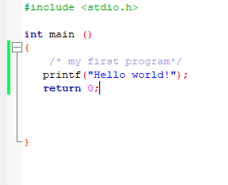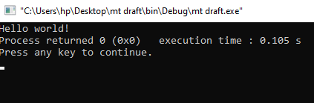

***MODULE 4: BASIC SYNTAX***



***MODULE 5: DATA TYPES***

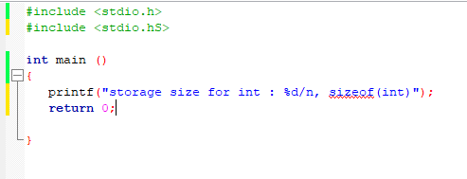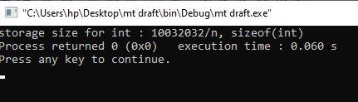

***MODULE 6: VARIABLES***

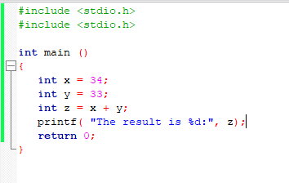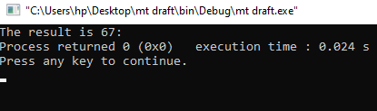

***MODULE 7: CONSTANTS AND LITERALS***

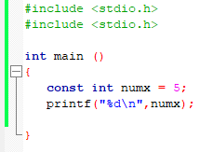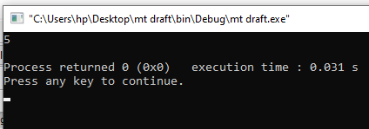

***MODULE 8: STORAGE CLASSES***

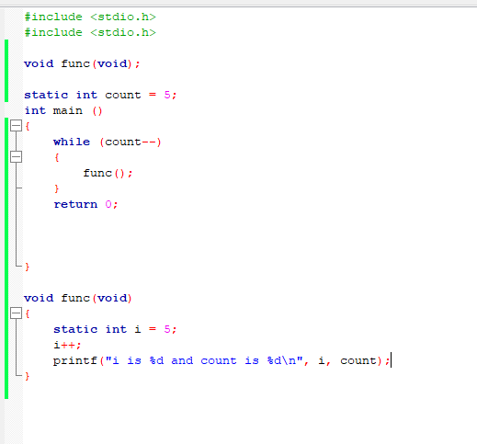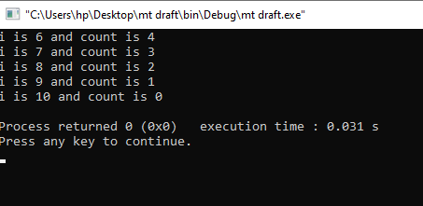

***MODULE 9: OPERATORS***

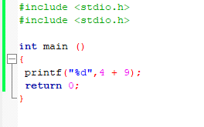 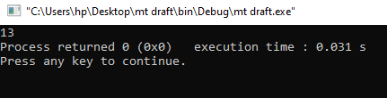

***MODULE 10: DECISION MAKING*** 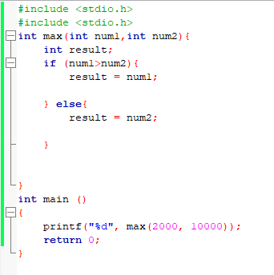 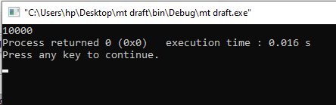

***MODULE 11: LOOP***

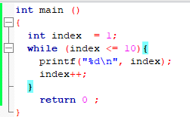 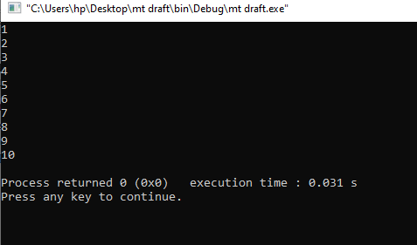 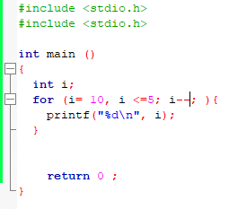

***MODULE12: FUNCTIONS***

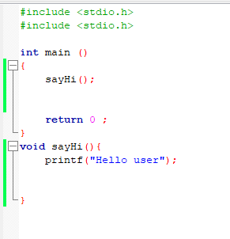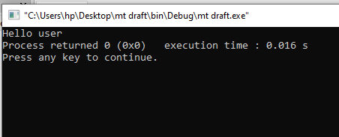

***MODULE13: SCOPE RULES***

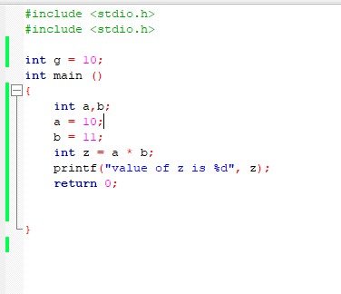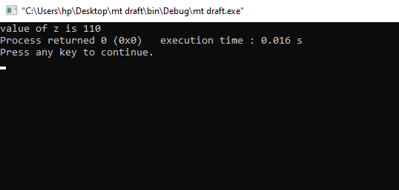

***MODULE14: ARRAYS***

